1. This is Wikipedia.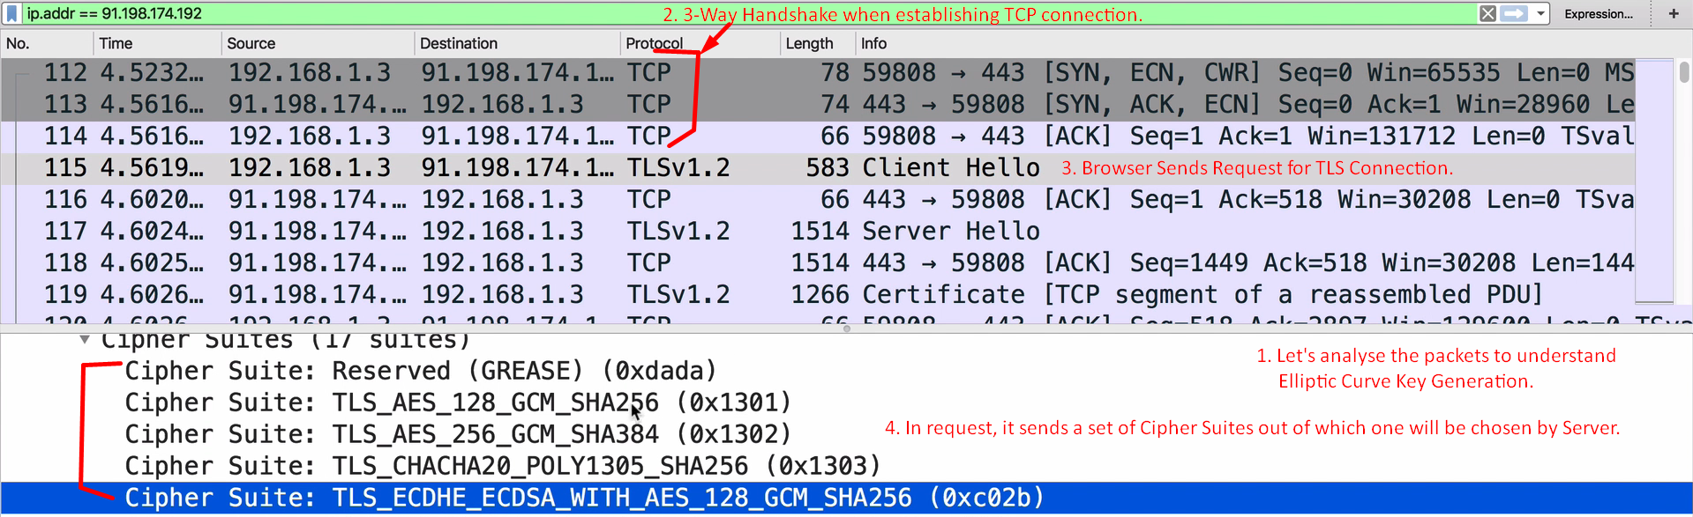
2. 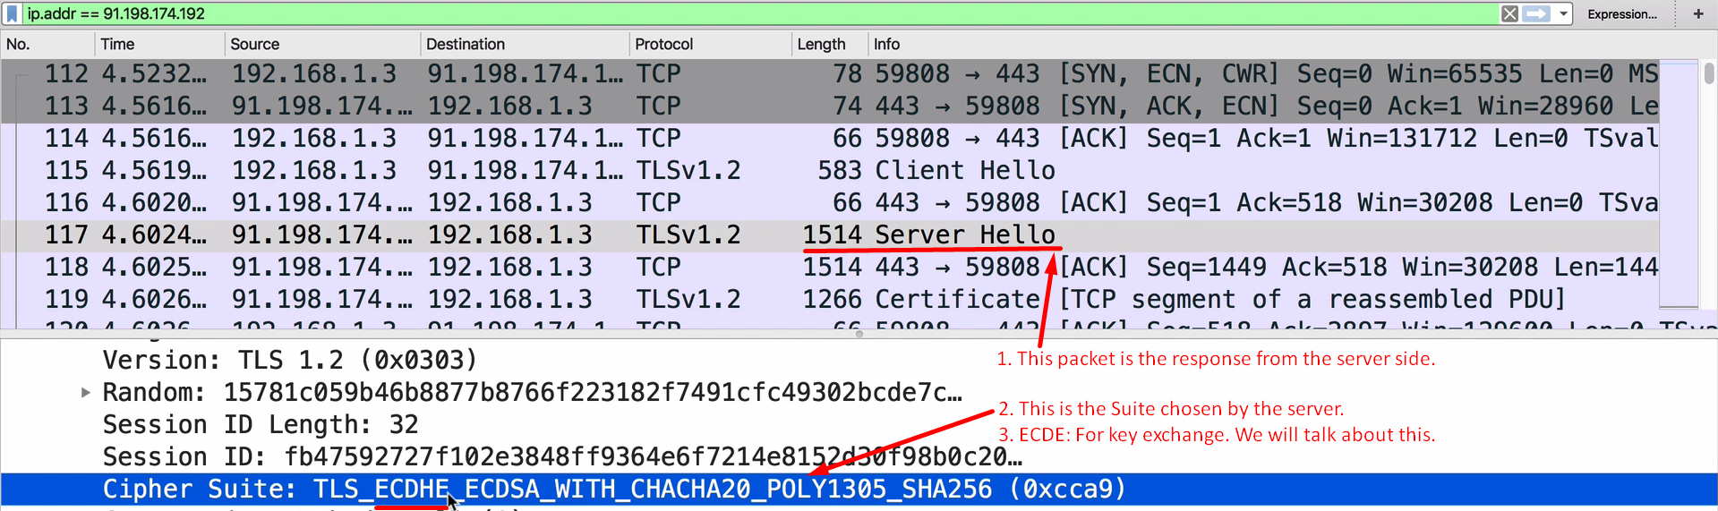
3. 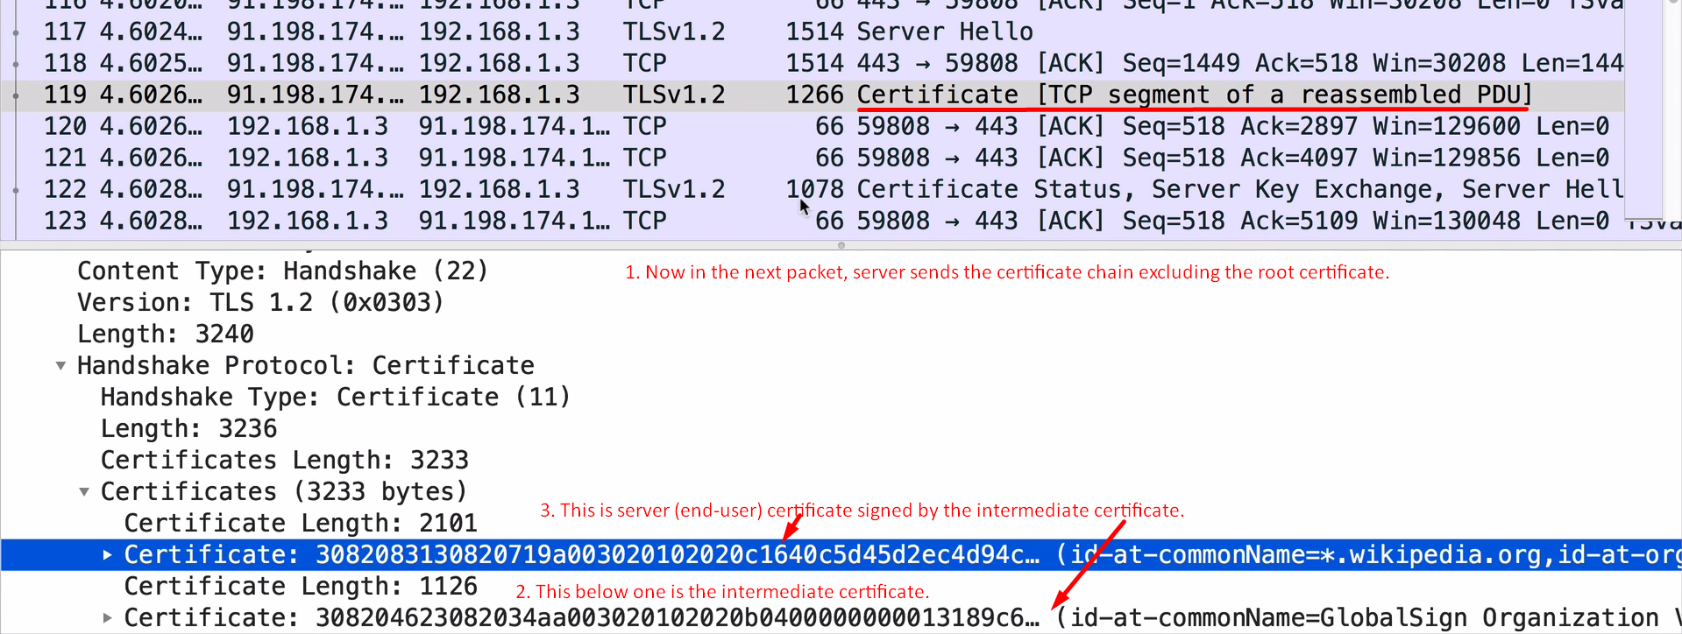
4. m